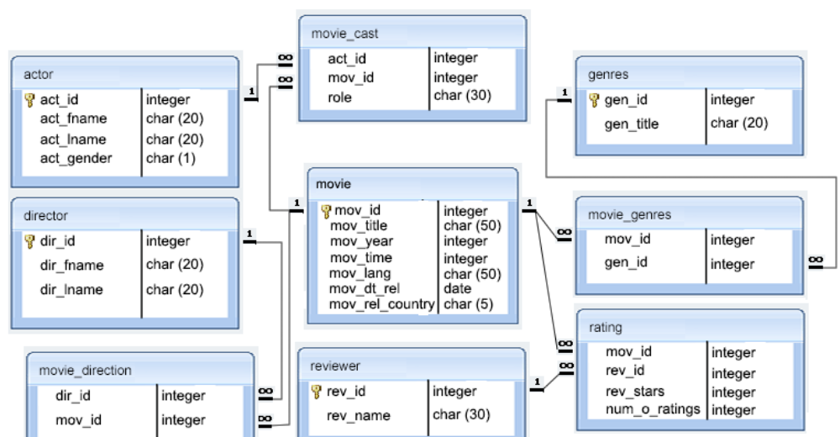

From above data model please write query to find –

1. Top 10 (based on rating) movies from “Comedy” Genre.
2. All the movies Directed by “Steven Spielberg”.
3. All the movies where “Samuel L. Jackson” acted as “Supporting Actor” role.
4. Find the directors & movie name who also acted on the same movie.
5. Find the name of director who created movie on all below 4 genre –
6. Horror
7. Comedy
8. Drama
9. Sci-Fi
10. Find the name pairs who played roles in maximum number of movies as “Leading Actor” & “Leading Actress.”
11. Find how many Bengali movies releases outside India.
12. Which year least number of movies had been released.
13. Find the Movie name & actor name where any Actor played role of multiple characters.
14. Which director has maximum number of movies with 5-star rating.
15. Top 10 (based on rating) movies from “Comedy” Genre.

select * from movie

join

rating ON movie.mov_id = rating.mov_id

join

movie_genres ON rating.mov_id = movie_genres.mov_id

join

genres ON movie_genres.gen_id = genres.gen_id

where

genres.gen_title = 'comedy'

ordered by

rating.num_o_ratings DESC